Overall

# **St Raphael Health – Website Creative & Style Guide Overview (For Designers)**

## **1. Purpose of the Website**

The St Raphael Health website must immediately establish:

* Credibility
* Calm authority
* Operational seriousness

This is **not a marketing website**.  
 It is a **trust-building platform** for high-stakes healthcare decision-makers.

The site must clearly communicate that St Raphael Health is:

* An **operator-led hospital advisory platform**
* Focused on **hands-on execution**, not consulting theory
* Built for **hospital leaders, boards, municipalities, physicians, and investors**
* Capable of stabilizing **distressed healthcare environments quickly and responsibly**

**Design goal:** Reassure first → Inform clearly → Invite conversation.

## **2. Overall Feel & Brand Personality**

### **Tone**

* Calm
* Confident
* Reassuring
* Executive-level
* Never promotional or sales-driven

### **What it should feel like**

* A trusted healthcare operating partner
* A steady presence in high-pressure environments
* Serious, composed, experienced

### **What it must NOT feel like**

* A tech startup
* A marketing agency site
* A private-equity pitch deck
* An emergency or trauma environment

## **3. Color System (From SRH Style Guide)**

The palette should be used **with restraint and hierarchy**, not saturation.

### **Primary Brand Colors**

* **Gold / Warm Ochre** #CBA85C  
  + Use sparingly for emphasis, dividers, icons, key metrics
* **Soft Gold** #EDBD56  
  + Secondary highlights, hover states, subtle accents

### **Support / Authority Colors**

* **Deep Red** #C2322F  
  + Used rarely; case study metrics, critical emphasis only
* **Dark Burgundy** #801B1F  
  + Optional depth for section headers or backgrounds

### **Neutrals (Primary Canvas)**

* **Black** #000000  
  + Headlines, primary text
* **Warm Stone / Light Taupe** #DBD5CA  
  + Section backgrounds, soft contrast blocks
* **White** #FFFFFF  
  + Primary background

**Important:** This site should skew **light, warm, and calm**, not dark or aggressive.

## **4. Typography**

### **Headlines**

* **Font:** Lounge (Regular)
* Use for:  
  + Page headlines
  + Section headers
* Spacing and line height should feel **editorial**, not tight

### **Body Copy & Subheadings**

* **Font:** Montserrat  
  + Light / Regular / Semibold / Bold as needed
* Highly readable
* Designed for **40+ executive audience**

Avoid:

* Condensed fonts
* Stylized display fonts
* Overuse of bold

## **5. Imagery & Photography Direction**

### **Use real, unstaged visuals**

* Hospital exteriors (daylight preferred)
* Natural-light corridors
* Clinicians in action (non-trauma)
* Leadership walking floors
* Diagnostics and operational workflows
* Community-focused environments

### **Imagery must feel**

* Real
* Calm
* Grounded
* Professional

### **Avoid**

* Emergency scenes
* Trauma or crisis imagery
* Posed stock photos
* Aggressive “growth” or finance visuals
* Over-edited or glossy stock imagery

This is about **trust and competence**, not drama.

## **6. Layout & UX Principles**

### **Overall Layout**

* Clean, editorial structure
* Generous white space
* Strong typography hierarchy
* Content-first design

### **Motion & Interaction**

* Subtle only:  
  + Soft fades
  + Gentle parallax
  + Light hover states
* No loud transitions
* No gimmicks

Every page should feel:

* Easy to scan
* Easy to trust
* Easy to continue reading

## **7. Navigation & Structure**

Navigation must be **consistent across all pages**.

Primary navigation includes:

* Hospital Advisory
* Our Approach
* Case Studies
* Team
* Why Profit Matters
* Physicians
* Contact

Avoid dropdown clutter.  
 This is a **serious executive audience**.

## **8. Homepage Design Direction**

The homepage is a **traffic director**, not a deep explainer.

### **Key requirements**

* Full-height **50 / 50 vertical split**
  + Left: Hospitals
  + Right: Physicians
* Subtle animated divider between the two
* Distinct but related visual language
* Clear CTAs for each path

### **Below the split**

* Inline contact form for uncertain visitors
* Minimal fields
* Calm reassurance language
* Emphasis on confidentiality

## **9. Forms & Contact Handling (Global)**

### **Form Design**

* Clean
* Minimal
* No friction

### **Tone**

* Discreet
* Respectful
* No urgency language
* No pressure

### **Delivery**

* To: info@saintraphaelhealth.com
* CC: Don

## **10. Footer (Global, Minimal)**

Footer must be identical across all pages.

Include:

* Privacy Policy
* Terms & Conditions
* Compliance

Displayed as simple text links.

**Contact Email**

* info@saintraphaelhealth.com

## **11. Content Philosophy (Critical for Designers)**

Design should reinforce that:

* **Profit is an enabler**, never the objective
* Community care and stability come first
* Case studies are factual, grounded, and metric-driven
* Claims are supported by real outcomes

Design should visually support:

* Execution
* Accountability
* Experience
* Stability

## **12. Final Guiding Principle (Design North Star)**

If a hospital CEO, board member, or municipal leader spends 30 seconds on the site, they should think:

“These people have been here before.  
 They understand pressure.  
 They move calmly.  
 And they know how to fix this.”

Every design decision should support that feeling.

Page 1

## **Above-the-Fold Layout**

**Full viewport height  
Split 50 / 50 vertically**

* Left: Hospitals
* Right: Physicians
* Soft animated divider or gradient line between the two
* Subtle motion on hover (no aggressive movement)

## **LEFT SIDE – HOSPITALS**

### **Visual Direction**

* Calm hospital exterior or executive team walking through a hospital corridor
* Clean lighting, neutral tones
* No emergency imagery
* Slow parallax or subtle fade-in animation

### **Headline**

**For Hospitals**

### **Blurb (Primary)**

Hands-on turnaround advisory for distressed hospitals.

### **Blurb (Secondary)**

Operators working alongside operators to restore profitability in months, not years, while strengthening patient care and community outcomes.

### **Micro-proof line (small text)**

200+ years of hospital operating and turnaround experience.

### **Primary CTA**

**Enter Hospital Advisory →**

(Button style: solid, confident, slightly heavier weight)

## **Left Panel – Hospitals**

**For Hospitals**

Hands-on turnaround advisory for distressed hospitals.

Operators working alongside operators to restore profitability in months, not years, while strengthening patient care and community outcomes.

**200+ years of hospital operating and turnaround experience.**

**Button:** **Enter Hospital Advisory →**

## **RIGHT SIDE – PHYSICIANS**

### **Visual Direction**

* Physician-led care environment
* Professional, composed, confident
* Focus on leadership, not procedures
* Slightly warmer tone than hospital side

### **Headline**

**For Physicians**

### **Blurb (Primary)**

Strategic support for physician groups and clinical leaders.

### **Blurb (Secondary)**

Operational alignment, growth strategy, and systems support designed to let physicians focus on care while strengthening long-term sustainability.

### **Micro-proof line (small text)**

Built by operators with deep healthcare and systems expertise.

### **Primary CTA**

**Enter Physician Advisory →**

(Button style: outlined or lighter to visually distinguish paths)

## **Right Panel – Physicians**

**For Physicians**

Strategic support for physician groups and clinical leaders.

Operational alignment, growth strategy, and systems support designed to help physicians focus on care while building sustainable, resilient practices.

**Built by operators with deep healthcare and systems expertise.**

**Button:** **Enter Physician Advisory →**

## **CENTER / SHARED ELEMENTS**

### **Top Center (or subtle overlay)**

**St Raphael Health**Advising healthcare organizations through challenge to strength.

## **BELOW THE SPLIT (Still on First Page)**

### **Inline Contact Form Section**

Clean, white background. Minimal fields.

**Section headline**Not sure where you fit?

**Subhead**Tell us a bit about your organization and we’ll guide you to the right place.

**Fields**

* Full Name
* Email
* Phone
* Organization / Hospital Name
* City / State
* Reason for Contact (dropdown)
* Message

**Submit button  
Contact Our Team**

**Delivery**

* To: info@saintraphaelhealth.com
* CC: Don

**Success message**Thank you. A member of our operating team will be in touch shortly.

## **Footer (Minimal on Entry Page)**

* Privacy Policy
* Terms & Conditions
* Compliance

(Clickable links only, no heavy legal text here)

## **Animation & UX Notes (Important)**

* Subtle hover glow or lift on each side
* Slight zoom or fade-in on page load
* No loud transitions
* Must feel **premium healthcare**, not tech startup

Hospital main page

### **Primary Menu**

1. **Hospital Advisory** (main landing page)
2. **Our Approach**
3. **Case Studies**
4. **Team**
5. **Why Profit Matters**
6. **Contact**
7. **Physicians**

# **St Raphael Health – Hospital Advisory (Primary Landing Page)**

This is the page someone lands on from the homepage or menu item **“Hospital Advisory.”**Its job is **clarity, authority, and conversion**, not depth.

## **1. Hero Section – Authority + Immediate Proof**

**Headline**We help distressed hospitals become profitable in months, not years.

**Positioning Sentence**We transform distressed Texas hospitals into profitable regional healthcare leaders, delivering exceptional patient care within their communities.

**Subhead**Our operating team with 200+ years of experience partners hands-on with Texas hospitals to restore profitability in under six months while delivering exceptional patient outcomes.

**Proof Strip (subtle animation)**

* $85M → $290M gross revenue, 19% profit margin
* $18M → $190M gross revenue, 12% profit margin
* $10M → $56M gross revenue, 32% profit margin

*Small text:* Documented hospital turnaround outcomes

**Primary CTA**Speak With Our Operating Team →

## **2. Who We Serve**

**Headline**Built for hospital environments under pressure.

**Hospitals & Operators**Hands-on operational leadership to stabilize performance and restore profitability.  
*Outcome:* Daily patient census increased 75%.

**Municipalities & Hospital Boards**Preserve community access to care while restoring financial health.  
*Outcome:* Reserves expanded by 150%.

**Investors & Lenders**Stabilized assets with improved margins and exit optionality.  
*Outcome:* Negative margins converted to double-digit profitability.

## **3. Our Approach (High-Level Only)**

**Headline**This is not consulting. This is execution.

**Copy**St Raphael Health embeds directly with hospital leadership teams to diagnose issues, drive operations, and deliver measurable results. We do not deliver reports and walk away. We stay accountable to outcomes.

**Embedded Proof Callout**“In only two years, emergency room visits increased 380%, surgical volume grew 300%, and inpatient census increased 14x.”

*(Deeper detail lives on the* ***Our Approach*** *page.)*

### **Why St Raphael Health Was Formed**

St Raphael Health was formed when a group of hospital operators and M&A professionals partnered with a Houston-based hospital CEO to help save a 270+ bed hospital operating under Chapter 11.

During that engagement, they uncovered a broader and deeply concerning reality. More than 60% of hospitals were operating in some level of distress, yet many could be stabilized quickly using a repeatable, operator-led framework focused on execution rather than theory.

They also discovered that many hospital owners wanted to sell or partner, but could not. Distressed operations meant little to no enterprise value, leaving communities, boards, and stakeholders with limited options.

St Raphael Health was created to address this gap — to restore hospitals to sustainable profitability first, protect patient care, and, where appropriate, help hospitals pursue strategic outcomes from a position of strength rather than distress.

## **4. Our Operating Pillars (Snapshot Only)**

**Headline**Our Operating Pillars

**6-Column Snapshot (icons + short copy)**

* **Cash Flow Acceleration**Turn revenue into predictable, reliable cash.
* **Cost Efficiency & Margin Improvement**Create durable margin expansion across operations.
* **Revenue Expansion**Grow top-line revenue through smarter operations.
* **Capital Structure Optimization**Strengthen the financial foundation for resilience.
* **Regulatory Compliance & Operational Integrity**Reduce risk and ensure operational stability.
* **Sale or Partnership (If Applicable)**Position stabilized hospitals for strategic outcomes.

*(Detailed explanations live on a supporting page or expand-on-scroll.)*

## **5. Case Studies (Anchor Preview Section)**

**Section Header**Proven Hospital Turnarounds

**Intro Line**Real-world outcomes achieved through hands-on operational leadership, not theory.

**Three-Card Preview (shortened)**

**BMC Hospitals | Greater Houston**$85M → $290M revenue · 19% margin · ER +380% · Surgical +300%

**Emergency Hospital Systems | Northeast Houston**$18M → $190M revenue · 12% margin · Profitability in 6 months

**Doctors Diagnostic Hospital | Cleveland, TX**$10M → $56M revenue · 32% margin · $18M profit achieved

*Link:* View Full Case Studies →

## **6. Micro Mission & Vision**

**Our Mission**Restoring hospital profitability to protect patient care and strengthen the communities they serve.

**Our Vision**A resilient, profitable network of exceptionally run hospitals delivering long-term value to patients, operators, and communities.

*Optional small line:* Profit enables care, stability, and choice.

## **7. Why Profit Matters (Teaser Only)**

**Headline**Why profitability is the foundation of every successful hospital.

**Short Copy**Profit is not the objective. It is the enabler of value, care, and operational stability.

*Link:* Explore Why Profit Matters →

## **8. Primary CTA**

**Headline**If your hospital is under pressure, speed matters.

**Subhead**Every month of delay reduces options. Early action creates leverage.

**CTA**Speak With Our Operating Team →

## **9. Contact (Preview CTA, Not Full Page)**

**CTA Line**Have a confidential conversation with our operating team.

**Button**Contact Us →

*(Full form lives on the dedicated* ***Contact*** *page.)*

## **10. Footer**

Privacy Policy · Terms & Conditions · Compliance  
info@saintraphaelhealth.com

## **Footer (Consistent Across Site)**

Privacy Policy · Terms & Conditions · Compliance  
info@saintraphaelhealth.com

Our approach

# **Our Approach**

## **Navigation (On-Page Anchors)**

* How We Work
* Our Operating Pillars
* Execution Model
* What Makes Us Different

## **Headline**

**This is not consulting. This is execution.**

## **Intro (Context + Tone Setting)**

St Raphael Health works alongside hospital leadership teams to stabilize operations, restore profitability, and create durable long-term value.

We do not advise from the sidelines. We embed directly, take responsibility for execution, and remain accountable for outcomes.

Our approach is built by operators, refined through real-world hospital turnarounds, and designed to move decisively in complex, high-pressure healthcare environments.

## **How We Work**

### **A disciplined, operator-led framework**

### **1. Rapid Diagnosis**

We begin by quickly identifying the operational and financial constraints preventing performance.

This includes:

* Cash flow and revenue cycle stress points
* Cost structures and margin leakage
* Service line performance
* Capital and balance sheet pressure
* Regulatory and operational risks

Our goal is clarity — fast.

### **2. Hands-On Operational Execution**

Once priorities are clear, we move immediately into execution.

We work directly with hospital leadership and teams to:

* Drive operational decisions
* Implement changes on the ground
* Remove friction across people, process, and systems

We do not deliver reports and disappear. We stay involved until change is real and measurable.

### **3. Profitability First**

Profitability is the foundation of every successful hospital outcome.

By restoring predictable cash flow and sustainable margins early, we:

* Stabilize day-to-day operations
* Reduce crisis management
* Create optionality for leadership

Profit enables better care, stronger teams, and long-term stability.

### **4. Build for Sustainability**

Stabilization is not the finish line.

We ensure:

* Operational improvements are repeatable
* Teams are aligned and supported
* Systems and processes are institutionalized

The objective is a hospital that performs without constant intervention.

### **5. Create Strategic Options**

Once operations are stable and profitability restored, leadership has choices.

Depending on objectives, we support:

* Long-term independent operation
* Strategic partnerships
* Sale or transaction at a materially improved valuation

Options only exist when operations are healthy.

## **Our Operating Pillars**

### **An integrated operating system, not standalone services**

Our approach is executed through a proven, repeatable operating framework.  
Each pillar reinforces the others and is applied based on urgency and context.

### **1. Cash Flow Acceleration**

Hospitals rarely fail due to lack of revenue. They fail because cash is delayed, trapped, or leaking through broken processes.

We rapidly convert earned revenue into usable cash by:

* Recovering aged receivables
* Tightening billing, coding, and collections cycles
* Improving payer responsiveness and escalation
* Addressing breakdowns in patient access and PFS

Cash flow is the fastest lever to restore control.

### **2. Cost Efficiency & Margin Improvement**

Distressed hospitals often carry cost structures misaligned with actual operating volume.

We create durable margin expansion by:

* Eliminating unnecessary or misaligned spend
* Optimizing purchasing and supply chain agreements
* Renegotiating vendor and service contracts
* Right-sizing overhead without compromising care

This is about alignment, not indiscriminate cuts.

### **3. Revenue Expansion**

Underperformance is often driven by underutilized capacity, not lack of demand.

We responsibly grow top-line revenue by:

* Strengthening provider networks
* Expanding or opening service lines aligned with community need
* Optimizing licensing and facility structures
* Ensuring full capture of services already delivered

Revenue growth supports reinvestment and long-term stability.

### **4. Capital Structure Optimization**

Many hospitals are constrained by misaligned capital and restrictive financial structures.

We strengthen the financial foundation by:

* Right-sizing the balance sheet
* Aligning lenders, investors, and stakeholders
* Structuring capital to support recovery and growth
* Creating flexibility for refinancing or future transactions

Capital should support operations, not constrain them.

### **5. Regulatory Compliance & Operational Integrity**

Operational distress often increases regulatory risk.

We ensure every clinical and administrative function meets required standards by:

* Addressing licensing and accreditation gaps
* Strengthening quality and safety frameworks
* Supporting survey readiness and audits
* Embedding compliance into daily operations

Operational integrity protects patients, staff, and leadership.

### **6. Sale or Partnership Strategy (If Applicable)**

Strategic outcomes are pursued only once stability is restored.

Where appropriate, we:

* Evaluate strategic alternatives
* Support partnership or sale discussions
* Position hospitals for materially improved valuation
* Help leadership pursue outcomes from a position of strength

Optionality is created through execution, not assumption.

## **Execution Model**

### **A disciplined operating model designed for speed and stability**

St Raphael Health operates using a structured execution model designed to stabilize hospitals quickly while building toward sustainable, long-term performance.

Every engagement follows the same core phases. The sequence may compress or overlap depending on urgency, but the discipline remains constant.

### **Phase 1: Immediate Stabilization (0–30 Days)**

**Objective:**Stop financial and operational bleed. Restore control.

**Focus Areas:**

* Cash flow visibility and short-term liquidity
* Critical vendor and payroll stabilization
* Revenue cycle triage
* Immediate compliance or operational risks
* Leadership alignment and decision clarity

**Outcome:**The hospital moves from reactive crisis management to controlled operations.

### **Phase 2: Performance Reset (30–90 Days)**

**Objective:**Restore predictable performance across core functions.

**Focus Areas:**

* Margin improvement and cost realignment
* Revenue cycle optimization
* Service line performance review
* Staffing and operational workflow stabilization
* Governance and reporting discipline

**Outcome:**The hospital operates with predictable cash flow, stabilized margins, and measurable performance improvements.

### **Phase 3: Sustainable Operations (90–180 Days)**

**Objective:**Embed systems and teams that perform without constant intervention.

**Focus Areas:**

* Institutionalized processes and controls
* Leadership capability and accountability
* Compliance readiness and quality frameworks
* Capital alignment and balance sheet health

**Outcome:**The hospital performs sustainably with reduced dependency on crisis intervention.

### **Phase 4: Strategic Optionality (Post-Stabilization)**

**Objective:**Create and evaluate long-term strategic choices.

**Focus Areas:**

* Independent growth planning
* Strategic partnerships
* Capital restructuring or refinancing
* Sale or transaction (if aligned with objectives)

**Outcome:**Leadership makes decisions from a position of strength, not distress.

## **What Makes This Different**

### **Operators, Not Advisors**

Our team brings over 200 years of combined hospital operating, turnaround, and transaction experience. We have worked inside these environments and understand what works under pressure.

### **Speed Without Chaos**

We move quickly, but not recklessly. Our framework prioritizes actions that matter most and avoids unnecessary disruption.

### **Accountability to Outcomes**

We measure success by results, not recommendations. Performance improvement, margin restoration, and operational stability are the benchmarks.

## **Proof in Practice**

“In only two years, emergency room visits increased 380%, surgical volume grew 300%, and inpatient census increased 14x.”

These outcomes are the result of disciplined execution, not theory.

## **Who This Approach Is For**

* Hospitals experiencing financial or operational distress
* Boards and municipalities seeking stability and accountability
* Investors and lenders requiring predictable performance
* Leadership teams who want partners, not consultants

## **Closing Section**

### **Headline**

If speed, accountability, and outcomes matter, our approach is built for you.

**CTA**Speak With Our Operating Team →

## **Footer (Consistent Across Site)**

Privacy Policy · Terms & Conditions · Compliance  
info@saintraphaelhealth.com

Case studies

# **Case Studies**

## **Headline**

Proven Hospital Turnarounds

## **Intro**

These case studies reflect real-world outcomes achieved through hands-on operational execution.  
 Every result below was delivered by experienced hospital operators working directly inside complex, distressed environments.

## **Case Study 1: BMC Hospitals**

**Location:** Greater Houston  
 **Profile:** Multi-facility surgical hospital system  
 **Challenge:** Financial distress, declining volumes, operational instability

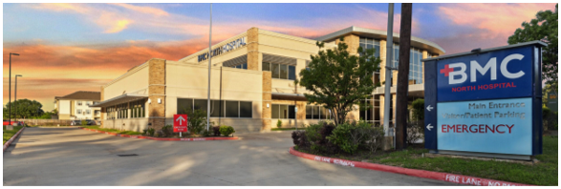

### **The Situation**

BMC Hospitals were operating under significant financial pressure, with declining margins, constrained cash flow, and limited capacity to invest in growth. Volumes were suppressed and the system lacked the operational leverage required to stabilize performance.

### **Our Approach**

St Raphael Health embedded directly with leadership to stabilize operations, restore financial discipline, and execute targeted growth initiatives across service lines.

### **The Results**

* Gross revenue growth from **$85M to $290M**
* Shift from negative margins to a **19% profit margin**
* Emergency room visits increased **380%**
* Surgical volume increased **300%**
* Inpatient census increased **14x**
* Healthcare workforce expanded to **290 FTEs**, strengthening community care delivery

## **Case Study 2: Emergency Hospital Systems (EHS)**

**Location:** Northeast Houston  
 **Profile:** Distressed hospital assets  
 **Challenge:** Bankruptcy risk, unsustainable operations, community access at risk

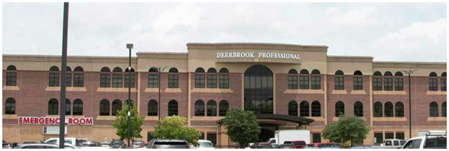

### **The Situation**

Emergency Hospital Systems faced severe financial distress, with limited operational flexibility and mounting pressure on leadership and stakeholders. Without intervention, essential community healthcare access was at risk.

### **Our Approach**

The focus was rapid operational stabilization, cash flow recovery, and margin restoration, executed alongside hospital leadership and clinical teams.

### **The Results**

* Gross revenue growth from **$18M to $190M**
* Shift from negative margins to a **12% profit margin**
* Profitability restored within **six months**
* Workforce expanded to **300+ employees**
* Multi-hospital system stabilized and positioned for long-term viability

## **Case Study 3: Doctors Diagnostic Hospital (DDH)**

**Location:** Cleveland, Texas  
 **Profile:** Community hospital  
 **Challenge:** Low volumes, limited reserves, constrained growth

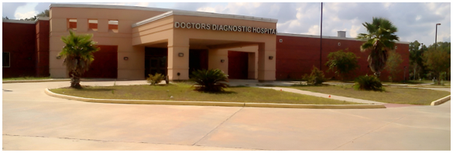

### **The Situation**

Doctors Diagnostic Hospital operated with modest volumes and limited financial reserves, restricting its ability to scale services and create shareholder value.

### **Our Approach**

St Raphael Health focused on operational efficiency, revenue expansion, and balance sheet strengthening to support sustainable growth.

### **The Results**

* Gross revenue growth from **$10M to $56M**
* Shift from negative margins to a **32% profit margin**
* Daily patient census increased **75%**
* Reserves expanded by **150%**
* **$18M in profit achieved**
* First-ever shareholder dividend distributed

## **What These Outcomes Demonstrate**

Across all case studies:

* Distressed operations were stabilized
* Profitability was restored
* Community healthcare access was strengthened
* Leadership regained strategic control
* Optionality was created for long-term operation or transaction

These outcomes were achieved through execution, accountability, and disciplined operational leadership.

## **Closing CTA**

### **Headline**

If your hospital is under pressure, proven execution matters.

**CTA** Speak With Our Operating Team →

### **Notes for build (non-visible)**

* Editorial, magazine-style layout
* Large metrics highlighted visually
* Calm hospital imagery (not emergency-focused)
* Consistent formatting across all case studies

## **Footer (Consistent Across Site)**

Privacy Policy · Terms & Conditions · Compliance  
info@saintraphaelhealth.com

Team

## **Team**

### **A seasoned operating and advisory team with proven hospital turnaround and platform-scale experience**

St Raphael Health is led by a deeply experienced operating and advisory team with over **200 years of combined healthcare leadership**, supported by a corporate development and capital markets bench with **$8B+ in transaction experience**.  
 The team has operated **14 hospitals**, led multiple distressed and bankrupt hospital turnarounds, and scaled platforms generating **$350–$400M in incremental annual revenue** while restoring profitability, compliance, and operational stability.

## **Operating Team**

### **Don Vickers**

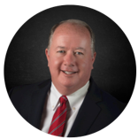

**Chief Executive Officer**

Don Vickers is a veteran hospital executive with more than 15 years of leadership experience across multi-facility healthcare systems. He has served as CEO of multiple hospitals, including St. Michael’s, BMC Heights, Altus Houston, and American Premier, leading complex turnarounds and growth initiatives.

Under Don’s leadership, distressed hospital systems have been scaled from **32 to 300+ staff**, revenues expanded materially, and physician networks aligned to drive sustainable growth. He has reopened and stabilized defunct hospitals, launched outpatient emergency departments, and led large-scale vaccination initiatives delivering over **40,000 COVID-19 doses**.

Don has deep expertise in accreditation, licensing, regulatory readiness, and physician alignment. He is a voting member of the **Texas Department of Health Services Syndromic Surveillance Governance Council** and holds advanced healthcare management credentials.

### **Patti Foster**



**Chief Operating Officer**

Patti Foster brings over 30 years of executive healthcare operations experience, with deep expertise in hospital administration, operational turnaround, and system-wide performance improvement. She has led complex healthcare organizations through periods of distress, restructuring, and growth.

Her leadership focuses on operational discipline, staffing optimization, regulatory compliance, and execution at scale across acute care hospitals and emergency facilities.

### **Robin Croninger Workman**

**Chief Revenue Cycle Officer**

Robin is a nationally recognized revenue cycle executive with **30+ years of experience** across for-profit and not-for-profit healthcare systems. Her expertise spans acute care hospitals, surgical hospitals, ASCs, CAHs, and large private practices.

She specializes in rapid diagnosis and correction of Patient Access and Patient Financial Services breakdowns, delivering immediate cash-flow impact and sustainable revenue performance. Robin has hands-on experience implementing and optimizing enterprise systems including **Epic, Cerner, Meditech, CPSI/TruBridge, Athena, NextGen, and SIS**.

### **Kimberly M. Harrington, MSN, BA, RN**



**Chief Quality Officer**

Kimberly Harrington is a senior clinical leader with **30+ years** of experience in hospital quality, nursing leadership, and emergency department operations. She has served as CNO, Chief Quality Officer, and ED Director across hospitals, surgical centers, and behavioral health systems.

She leads quality, infection control, regulatory compliance, and board-level reporting across multi-site operations. Known for ED turnarounds, Kimberly has consistently improved patient satisfaction, reduced wait times, and strengthened regulatory readiness.

### **Suzi Halfpenny**



**Head of Asset Management & Operations**

Suzi brings deep private equity and asset management experience, having played a key role in scaling a firm from **$500M to over $2B AUM**. She has led the implementation of institutional-grade controls, workflows, and governance frameworks to support rapid platform growth.

Her background includes supporting over **$1B in fundraising initiatives**, optimizing operational processes, and building scalable teams across complex asset portfolios.

### **Greg Rook**



**Corporate Finance**

Greg Rook is a senior finance and data strategy leader with over a decade of experience across private equity, FP&A, and capital planning. He previously built and led an asset performance team overseeing **$10B in assets**, driving finance system overhauls, analytics integration, and underwriting optimization.

He is a CPA/CA with advanced expertise in institutional reporting, performance analytics, and platform-scale financial operations.

### **Thomas Le Maguer**



**Head of Corporate Development**

Thomas brings deep experience in M&A, growth strategy, and platform creation. He has led **13 acquisitions totaling over $1.2B** in transaction value and supported roll-ups generating $10M+ EBITDA.

He has also built performance-driven growth systems for over **900 businesses**, generating more than **$750M in client revenue**, and founded and exited multiple ventures across marketing, finance, and capital deployment.

### **Adam Hollander**



**Vice President of Integrations, Partner**

Adam is a post-acquisition integration specialist with experience leading **$1.5B+ in integrations** across North America, Europe, Australia, and South Africa. He has managed complex M&A integrations, including a **$500M acquisition** in the financial systems sector, ensuring operational continuity and value realization post-close.

### **Eric Mui**



**Vice President of Finance**

Eric is a finance leader with a strong background in operational efficiency, audit readiness, and scalable financial systems. He has successfully scaled early-stage operations, optimized mid-market finance teams, and built reporting frameworks covering project profitability, forecasting, and executive decision support.

### **Robin Mason**



**Healthcare Human Resources**

Robin Mason brings **25+ years of healthcare operations and HR leadership**, with experience across hospitals, surgical centers, and regional health systems. She has led post-merger integrations, workforce alignment initiatives, and multi-facility operational turnarounds.

Her expertise includes surgical services optimization, OR utilization, compliance leadership, and accreditation readiness across DNV, Joint Commission, and state and federal audits.

### **Greg Shore**

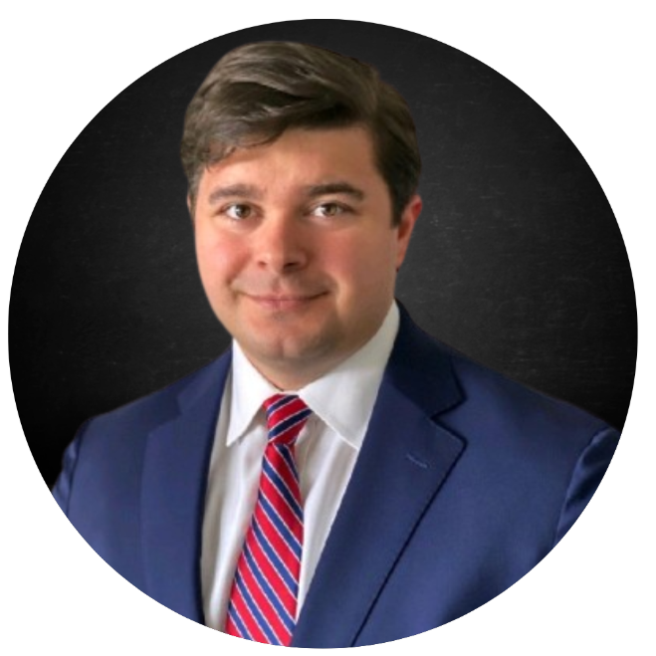

**Managing Capital Director**

Greg Shore is a capital markets and development executive with experience structuring and financing complex projects across healthcare, real estate, energy infrastructure, and private-equity-backed platforms.

### **Nick van Zyl**



**Head of AI & Business Automation**

Nick leads SRH’s automation, systems integration, and AI infrastructure. With a background in banking-grade development, he designs secure, scalable systems that automate operations, integrate enterprise platforms, and support institutional reporting.

His work focuses on reliability, security, and operational leverage across SRH’s hospital platform.

### **Tanya van Zyl**



**Director of Marketing**

Tanya leads brand strategy, communications, and growth initiatives for St Raphael Health. With over 20 years of experience in strategic marketing, lead generation, and positioning, she ensures SRH is clearly positioned as a trusted operator-led healthcare platform for hospital owners, investors, and partners.

## **Advisory Team**

### **Uri Levine**

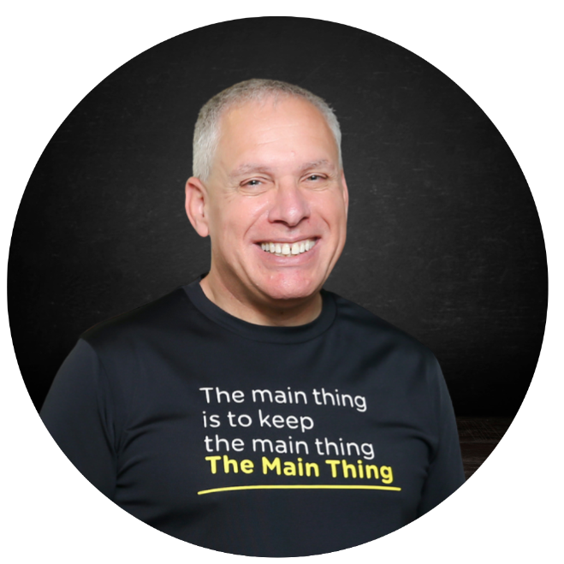

**Technology Advisor**

Co-founder of **Waze** (acquired by Google for $1.1B) and **Moovit** (acquired by Intel for $1B), Uri brings decades of experience building and scaling technology platforms that solve complex systemic problems.

### **Michael Hiley**



**Private Equity, Accounting & Tax**

Michael is a senior partner at BDO Canada LLP with over **20 years** of public accounting experience, specializing in private equity, complex financial reporting, and institutional compliance across public and private entities.

### **David F. W. Cohen**

**Restructuring Advisor**

David leads Financial Institutions and Restructuring at Gowling WLG and is a former President of the Turnaround Management Association. He has advised on major cross-border restructurings, including **$1.8B+ transactions**, and complex secured financings.

### **Paul Van Eyk**



**Global Restructuring Advisor**

Paul is Global Head of Restructuring and Turnarounds at KPMG, advising boards, lenders, and investors on enterprise transformation, value creation, and post-merger integration across large-scale platforms.

## **Footer (Consistent Across Site)**

Privacy Policy · Terms & Conditions · Compliance  
info@saintraphaelhealth.com

Why profit matters

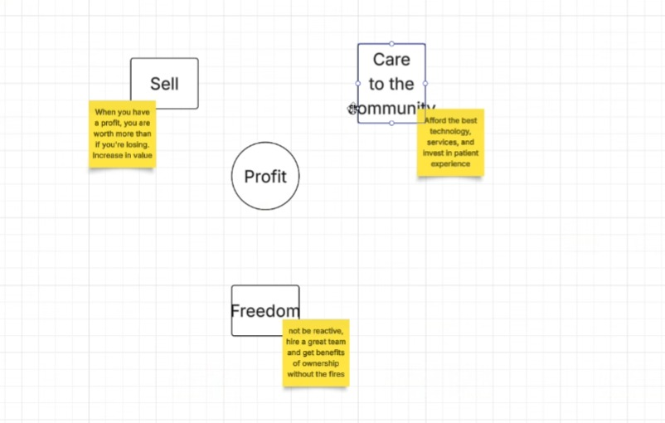

# **Why Profit Matters**

## **Headline**

**Profitability is not the objective. It is the enabler.**

## **Introduction**

In healthcare, profit is often misunderstood.

At St Raphael Health, profitability is not about extracting value from communities. It is about **protecting patient care**, **preserving access**, and **creating stability** in hospital environments under constant operational and financial pressure.

Without sustainable profit, hospitals lose options.  
 With it, they gain control.

## **The Reality Facing Hospitals**

Across the United States, the majority of hospitals operate under some level of financial distress.

When margins are negative or unpredictable:

* Capital becomes constrained
* Staff turnover increases
* Technology investment stalls
* Community trust erodes
* Strategic choices disappear

Profitability is the difference between **constant reaction** and **effective leadership**.

## **Profit Enables What Matters Most**

### **1. Care for the Community**

Sustainable profit allows hospitals to:

* Invest in modern equipment and technology
* Recruit and retain high-quality clinical staff
* Expand service lines that meet real community needs
* Improve patient experience and outcomes

Care improves when hospitals are financially stable.

### **2. Freedom and Stability for Leadership**

When a hospital is profitable:

* Leaders can plan instead of firefighting
* Decisions are proactive rather than forced
* Teams operate with clarity and confidence
* Governance becomes strategic instead of defensive

Profit restores operational freedom.

### **3. Value Creation and Strategic Options**

Profitability creates optionality.

Stable, well-run hospitals can:

* Remain independent
* Form strategic partnerships
* Access capital on better terms
* Pursue a sale at a materially higher valuation

Without profit, these options do not exist.

## **Profit Is the Enabler**

*(Diagram Section)*

**Center:** **Profit** *Sustainable profitability*

Profit sits at the center because everything else depends on it.

**Sell / Value Creation** When a hospital is profitable, it is worth more than when it is losing money. Profitability restores enterprise value and creates real strategic options, including partnership or sale.

**Care for the Community** Profit enables investment in staffing, technology, services, and patient experience, directly improving the quality of care delivered.

**Freedom & Stability** Profit allows leadership to operate proactively instead of reacting to constant crisis, creating stability for teams, governance, and long-term planning.

## **The Core Principle**

Whether the goal is to:

* Protect essential community healthcare
* Restore operational control
* Stabilize a distressed facility
* Or prepare for a future transaction

**Profitability is the starting point.**

That is why St Raphael Health focuses first on restoring sustainable profit — not as an end in itself, but as the foundation for care, stability, and long-term value.

## **Pull Quote (Optional Callout)**

Profit is not the objective.  
 It is the enabler of care, stability, and choice.

## **Closing Section**

### **Headline**

Hospitals cannot serve their communities without financial strength.

**CTA** Speak With Our Operating Team →

## **Mobile Version (Stacked Explanation)**

**Profit Is the Enabler**

Profitability is not the goal.  
 It is what makes everything else possible.

**Care for the Community** Profit allows hospitals to invest in staff, technology, services, and patient experience so communities receive consistent, high-quality care.

**Freedom & Stability** Profit enables leadership to plan ahead instead of reacting to constant crisis. Teams are stronger, turnover is lower, and decisions are proactive.

**Value Creation** When hospitals are profitable, they gain options. They can remain independent, form partnerships, or pursue a sale from a position of strength.

**Bottom Line** Whether the goal is care, stability, or strategic options, profitability is the starting point.

## **Build Notes (Non-Visible)**

* Place after **Case Studies**
* Pair with a simple, calm diagram (no aggressive finance visuals)
* Soft color palette, strong typography
* Readable and reassuring for a 40+ healthcare audience
* Should feel **credible and steady**, not transactional

## **Footer (Consistent Across Site)**

Privacy Policy · Terms & Conditions · Compliance  
info@saintraphaelhealth.com

Contact page

# **Contact**

## **Headline**

Start the conversation.

## **Intro Copy**

If your hospital, health system, or community is under operational or financial pressure, an early conversation can create options.

St Raphael Health works confidentially with hospital leadership, boards, municipalities, and investors to assess situations, stabilize operations, and restore control.

## **Contact Form**

**Form Fields**

* Full Name
* Email Address
* Phone Number
* Organization / Hospital Name
* City / State
* Message

**Optional Dropdown – Reason for Contact**

* Advisory Services
* Hospital Partnership
* Investor Inquiry
* Municipality / Board Inquiry
* Media / Press
* Other

**Consent Checkbox**“I agree to be contacted by St Raphael Health regarding my inquiry.”

**Submit Button**Submit Inquiry →

## **Direct Contact**

If you prefer, you may contact us directly:

**Email**info@saintraphaelhealth.com

All inquiries are treated as confidential.

## **What Happens Next (Reassurance Section)**

After submitting your inquiry:

* A member of our operating team will review your message
* We will respond promptly and discreetly
* No obligation, no pressure

Our goal is to understand your situation and determine whether we can be helpful.

## **Footer (Consistent Across Site)**

Privacy Policy · Terms & Conditions · Compliance  
info@saintraphaelhealth.com

Privacy Policy

Privacy Policy

Terms & Conditions

Compliance